CIS 22C-03Y TTh 1:30-3:20 PM
Class Notes for 06-08-2017
==========================================
FINAL EXAM will be on TUESDAY, JUNE 27, 1:45 - 3:45 PM (more details next 2 weeks, review on Thurs., June 22

==========================================
ANSWERS TO LAB EXERCISE 9.1:
Do a Single right rotation at B in the tree below. Show the result either on a computer, or draw by hand and take a picture of it.
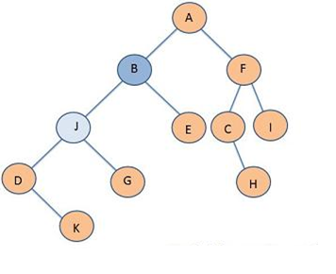

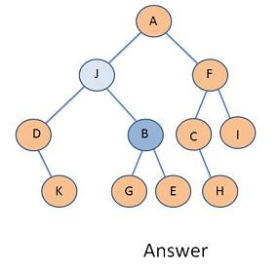

==========================================
ANSWERS TO LAB EXERCISE 9.2:
Do a Left-right rotation (D, then B) for the tree below. Show the result either on a computer, or draw by hand and take a picture of it.
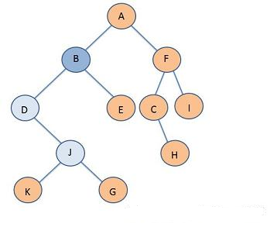
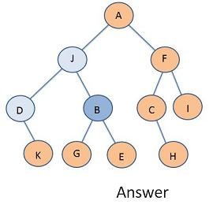

==========================================
IN-class Exercise given 06-06-2017:

Use rotateWithLeftChild and rotateWithRightChild (using an external AVL_Node) looks like: (will need to use accessors and mutators, too)

// THIS IS WHAT I CALLED Right Rotation at k2
protected AVL_Node<E> rotateWithLeftChild(
AVL_Node<E> k2 )
{
AVL_Node<E> k1 = k2.getLeftChild();
k2.setLeftChild(k1.getRightChild());
k1.setRightChild(k2);
k2.setHeight( Math.max( heightOf(k2.getLeftChild()), heightOf(k2.getRightChild()) ) + 1 );
k1.setHeight( Math.max( heightOf(k1.getLeftChild()), k2.getHeight() ) + 1 );
return k1;
}

// What I called Left Rotation at k2
protected AVL_Node<E> rotateWithRightChild(
AVL_Node<E> k2 )
{
AVL_Node<E> k1 = k2.getRightChild());
k2.setRightChild(k1.getLeftChild());
k1. setLeftChild(k2);
k2.setHeight( Math.max( heightOf(k2.getLeftChild()), heightOf(k2.getRightChild()) ) + 1 );
k1.setHeight( Math.max( heightOf(k1.getRightChild()), k2.getHeight() ) + 1 );
return k1;
}
Calling the rotateWithLeftChild() and rotateWithRightChild() methods given in the Class Notes for 6-06-2016, write the leftRightRotate and rightLeftRotate methods using the following headings and descriptions:
protected AVL_Node<E> doubleWithLeftChild(
AVL_Node<E> k3 )
// do a single LEFT rotation passing k3's left child, then return the result of calling rotateWithLeftChild passing the parameter
protected AVL_Node<E> doubleWithRightChild(
AVL_Node<E> k3 )
// do a single RIGHT rotation passing k3's right child, then return the result of calling rotateWithRightChild passing the parameter

ANSWERS:

// What I called Left-Right double rotation:
protected AVL_Node<E> doubleWithLeftChild(
AVL_Node<E> k3 )
{
k3.setLeftChild(rotateWithRightChild(k3.getLeftChild()));
return rotateWithLeftChild(k3);
}

// What I called Right-Left double rotation:
protected AVL_Node<E> doubleWithRightChild(
AVL_Node<E> k3 )
{
k3.setRightChild(rotateWithLeftChild(k3.getRightChild()));
return rotateWithRightChild(k3);
}
Example of a call, where k3's parent is called node:
node.setLeftChild(doubleWithLeftChild(node.getLeftChild());
==========================================
HW#5
Questions?

If you're not sure what a collision is in HashSC, ask in THE FORUM for HW#5

If you haven't finished HW#4, ask for help!

==========================================
Lesson 10 HEAPS

Here is possible Java code for a MinHeap:

// Binary Min Heap, starts at element 0
import java.util.Arrays;

public class BinaryHeap<T extends Comparable<T>> {
private static final int DEFAULT_CAPACITY = 10;
protected T[] array;
protected int size;

/**
* Constructs a new BinaryHeap.
*/
@SuppressWarnings("unchecked")
public BinaryHeap () {
// Java doesn't allow construction of arrays of placeholder data types
array = (T[])new Comparable[DEFAULT_CAPACITY];
size = 0;
}

/**
* Adds a value to the min-heap.
*/
public void add(T value) {
// grow array if needed
if (size >= array.length) {
array = this.resize();
}

// place element into heap at bottom
int index = size;
array[index] = value;
++size;

percolateUp();
}

/**
* Returns true if the heap has no elements; false otherwise.
*/
public boolean isEmpty() {
return size == 0;
}

/**
* Returns (but does not remove) the minimum element in the heap.
*/
public T peek() {
if (this.isEmpty()) {
throw new IllegalStateException();
}

return array[0];
}

/**
* Removes and returns the minimum element in the heap.
*/
public T remove() {
// what do want return?
T result = peek();

// get rid of the last leaf/decrement
array[0] = array[size-1];
array[size-1] = null;
--size;

percolateDown();

return result;
}

/**
* Returns a String representation of BinaryHeap with values stored with
* heap structure and order properties.
*/
public String toString() {
return Arrays.toString(array);
}

/**
* Performs the "percolate down" operation to place the element that is at the
* root of the heap in its correct place so that the heap maintains the
* min-heap order property.
*/
protected void percolateDown() {
int index = 0;

// percolate down
while (hasLeftChild(index)) {
// which of my children is smaller?
int smallerChild = leftIndex(index);

// percolate with the smaller child, if I have a smaller child
if (hasRightChild(index)
&& array[leftIndex(index)].compareTo(array[rightIndex(index)]) > 0) {
smallerChild = rightIndex(index);
}

if (array[index].compareTo(array[smallerChild]) > 0) {
swap(index, smallerChild);
} else {
// otherwise, get outta here!
break;
}

// make sure to update loop counter/index of where last el is put
index = smallerChild;
}
}

/**
* Performs the "percolate up" operation to place a newly inserted element
* (i.e. the element that is at the size-1 index) in its correct place so
* that the heap maintains the min-heap order property.
*/
protected void percolateUp() {
int index = this.size - 1;

while (hasParent(index)
&& (parent(index).compareTo(array[index]) > 0)) {
// parent/child are out of order; swap them
swap(index, parentIndex(index));
index = parentIndex(index);
}
}

protected boolean hasParent(int i) {
return i > 0;
}

protected int leftIndex(int i) {
return i * 2 + 1;
}

protected int rightIndex(int i) {
return i * 2 + 2;
}

protected boolean hasLeftChild(int i) {
return leftIndex(i) < size;
}

protected boolean hasRightChild(int i) {
return rightIndex(i) < size;
}

protected T parent(int i) {
return array[parentIndex(i)];
}

protected int parentIndex(int i) {
return (i - 1) / 2;
}

protected T[] resize() {
return Arrays.copyOf(array, array.length * 2);
}

protected void swap(int index1, int index2) {
T tmp = array[index1];
array[index1] = array[index2];
array[index2] = tmp;
}
}

QUESTIONS:

- how could you use the above heap class for a priority queue?
- ideas:
  - write a PriorityQueue class with a data generic type <E>
  - write an inner class (like HashEntry in HashQP) for QueueEntry (implements Comparable<QueueEntry> that has <E> and an int for priority (lowest # first)
  - override compareTo so it compares priority, then E
  - INCLUDE a BinaryHeap<QueueEntry> instance variable
- how could you prevent duplicate priority values?

HEAP SORT

NOTE: an IN-CLASS exercise for Max-Heap and Heap sort is due BEFORE CLASS on Tuesday!
==========================================
TEAM PROJECT
- Graph problems HAVE BEEN ASSIGNED (see separate Catalyst link)!
- Team Report #3 is due next week on MONDAY (see file on Catalyst)

EXAMINE THE Graph.java CODE from the Team Projects Code Folder NOW!

==========================================
IN-CLASS EXERCISE DUE BEFORE CLASS ON Tuesday (06-13):

By hand (no program involved, nor web site): put these numbers into a heap (but show in an array) in the order given here, showing the resulting array after each addition: 65 45 70 50 85 55 60 75 80

After you create the heap, show the steps (one element at a time) to sort the heap, using the heapsort algorithm given in LESSON 10, page 10.3 (the one that creates a Max Binary Heap first).
You may write this by hand and upload a picture, or type into the computer and upload a Word document or text document.
==========================================
TO DO THE REST of THIS WEEK and NEXT WEEK:
- Turn in LAB EXERCISES 10.1 (CUT-OFF TONIGHT 11:55 PM)
- Turn in Lab Ex. 10.2 (due Saturday night 11:55 PM)
- Finish HW#5! (DUE TONIGHT!)
- READ LESSON 12 for MONDAY!
- MEET with your team members to work on Team Report #3!
Submit Team Project Report #3 (due Monday night)!

==========================================

